Window: Pantalla on es projecten els punts
Finestra opengl: tota la finestra, la aplicació
Viewport: part de la finestra on es veu la imatge

Four types:
– Similarity: The icon is visually similar to the action/object to be represented. Adequate for simple objects (turn right)
– Example: Elements can be related to the image (plane for airport)
– Symbolic: High level of abstraction (unlock icon)
– Arbitrary: No relationship with element or action (nuclear symbol)

A l’hora de fer un rotate l’objecte ha d’estar centrat al (0,0,0)

transform → modelmatrix → pinta()
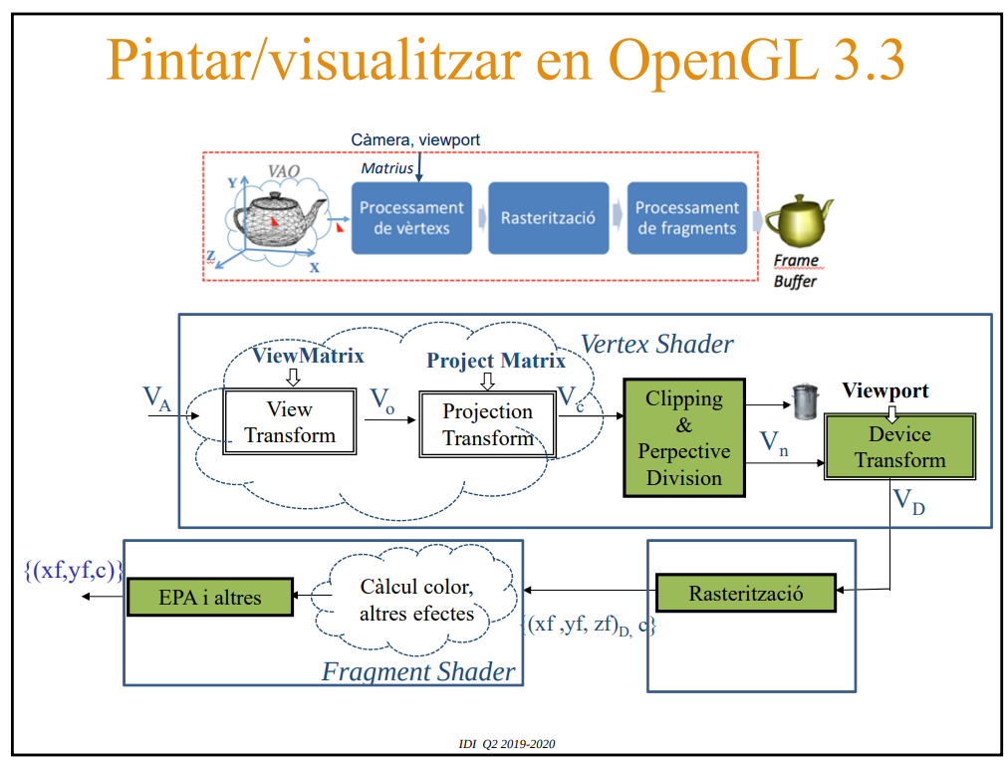

void main() {

gl_Position = PM*VM*TG*vec4 (vertex, 1.0);

}

MATEIX algorisme de clipping SEMPRE

